RIPE FOR HARVEST EMPLOYEE DIRECT DEPOSIT AUTHORIZATION
In order to provide you with direct deposit of your paychecks, we must have a completed and signed original of this form.


Employer: RIPE FOR HARVEST

Employee

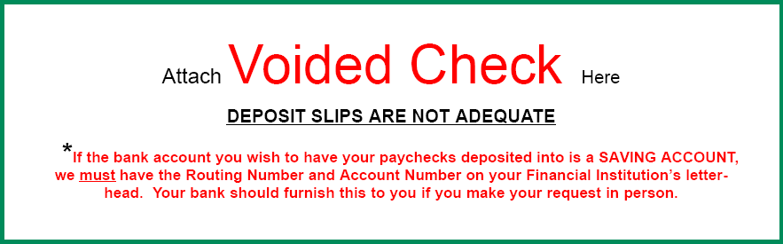

If you don’t have a physical check, please type in your Routing Number and Account Number.

Routing Number:

Account Number:

I hereby authorize Ripe For Harvest, Cedarstone and its agents, including financial institutions, to initiate electronic credit entries and, if necessary, debit entries and adjustments for any credit entries resulting from a payroll payment error to my checking or savings account listed above and to collect appropriate fees and charges. I understand that this authorization shall remain in effect until I have canceled it in writing.

Please scan and email to: rfhgregg@gmail.com

